a)

b) Before

After

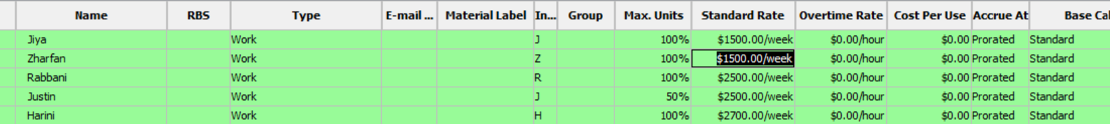

c) 

d)

Before

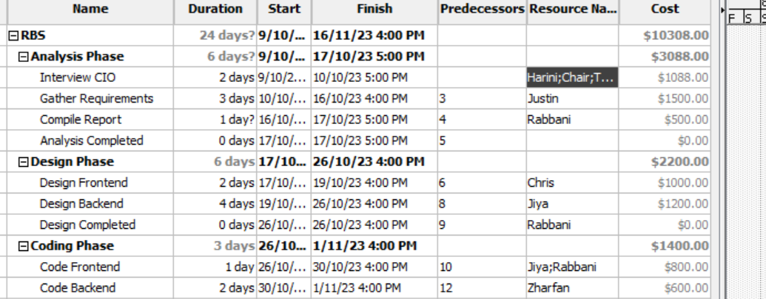After